UNIVERSITY OF MINNESOTA COLLEGE OF VETERINARY MEDICINE

Request form for free quantitative urolith analysis

Please send stones DRY (not in formalin), and in an UNBREAKABLE container.

Please do not send urine samples or sediment. Please label the sample with the **ANIMAL’S NAME** , and the **OWNER’S SURNAME**

Urinary pH at, or just prior to, urolith removal Previous uroliths? Yes No

**SUBMITTED BY VETERINARY SURGEON:**

Mr Mrs Miss Ms Dr* Date

Surname

Practice Name

EMAIL:

Postcode

Telephone Number

Facsimile Number

If yes, date of detection If yes, what was the composition?

Owner’s Name Owner’s Address

Animal’s Name

Was the urine cultured prior to stone retrieval? Yes No Bacterial growth? If yes, isolates

Were antibiotics given prior to stone retrieval? Yes No If yes, type Dosage Were urinary acidifiers or alkalinizers given prior to stone retrieval?

Yes No If yes, type

Species

DOG / CAT *please do not send other species without calling customer service

Dosage

Was allopurinol given prior to stone retrieval? Yes No

Breed (specific)

Birth Date Gender M MC F FS UNK

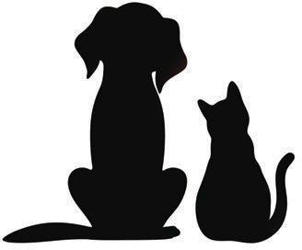Source: Renal pelvis Ureter Bladder Urethra Voided

Other Date voided or removed What food was fed prior to urolith diagnosis?

Approximately how long was the patient fed this food?

Was a Hill’s ™ Prescription Diet™ product fed? Yes No If yes, which one?

If yes, dosage and duration

**Previous illness or injury**

Diagnosis Date Diagnosis Date Patient’s current body weight

Underweight Normal Overweight

Dry Canned Dry Canned

Canine c/d Feline c/d Multicare

Canine s/d Feline k/d

Canine u/d Feline s/d

Other If yes, how long was the Prescription Diet ™ product fed?

From To

[WWW.VETMARKET.CO.IL](http://WWW.VETMARKET.CO.IL/) +972-3-9393000